Ideation Phase
Empathize & Discover

Date | 19 February 2026
Team ID | LTVIP2026TMIDS24279
Project Name | FreelanceFinder: Discovering Opportunities, Unlocking Potential
Maximum Marks | 4 Marks

Empathy Map Canvas:
In the SB Works – Revolutionary Freelancing Platform project, we empathized with fresh graduates like Sarah and local business owners to understand their daily challenges in navigating the competitive gig economy and finding reliable talent. Using the Empathy Map Canvas, we identified key frustrations such as the difficulty of building a portfolio from scratch, the anxiety of secure payment transactions, and the friction of disjointed communication.
Our users think about how to stand out in a crowded market, say they need a platform that prioritizes transparency and integrity, do repetitive manual searches for the "perfect" project match, and feel overwhelmed by the complexity of managing professional collaborations. For example, a freelancer often spends hours drafting proposals without knowing if their skills truly align with the client's brand identity, a process we optimized with integrated chat systems and detailed project briefings. This understanding informed the development of SB Works, a MERN-stack platform that streamlines the freelancing lifecycle to foster trust, boost professional growth, and ensure a secure, dynamic environment for all.

Example:
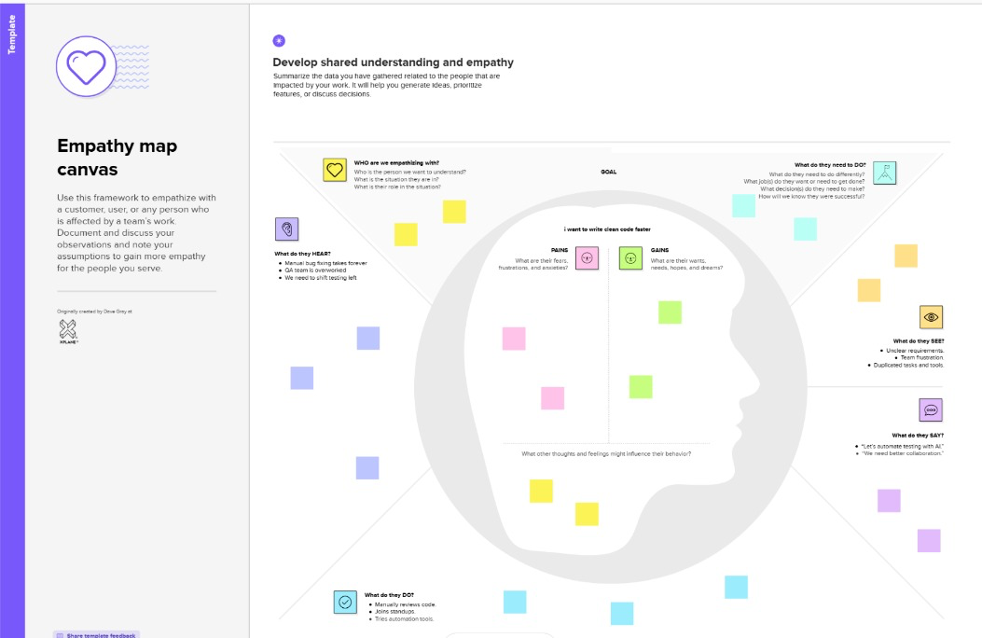

Reference: https://www.mural.co/templates/empathy-map-canvas

Example: Food Ordering & Delivery Application
